

Design Test

**Part 1: Answer the following questions in one or two paragraphs each:**

1. **What is your favorite non-Call of Duty single player experience and why? What part of the experience fell short of your expectations? What would you have changed?**

*Passage* is my favorite non-Call of Duty single player experience. Every decision the player makes is meaningful and will result in a different interpretation of the game. The game’s use of death is very powerful and may wash away everything the player has accomplished. These aspects of *Passage* create strong resonance and empathy between the player and the protagonist and make the player ponder the meaning of the game. Although I love these aspects of *Passage*, the incentive system of *Passage* felt monotonous and useless. As the player goes deeper down the maze, the only rewards he/she gets are meaningless stars that do not affect gameplay. If I were to change the incentive system, I would make the rewards the player gets have a significant impact on the character. For example, every time the player opens a chest, he/she gets to change the character’s appearance, such as wearing a fancier suit or gaining new accessories. This way the player is more likely to search for the rewards and the use of death would have a stronger effect on the player’s emotion.

1. **You are asked to design the first fifteen minutes of the second hour of gameplay in a standard FPS campaign [ex: Call of Duty]. More specifically, you are asked to avoid using any run-and-gun first person shooter combat. What would be your design methodology in approaching this task?**

Generally, I would merge other game types (e.g. Stealth, Action, Tower Defense) into the fifteen minutes’ gameplay, based on the storyline. First, I would read the storyline skeleton and decide where my fifteen minutes of gameplay would fall on. Based on that, I would choose what other game types work well with this part of the storyline and create the merged core mechanics. For example, if the plot suggests that the player should protect a target, I would merge static sniping into the campaign where the player should not leave a certain high ground area and use a sniper rifle to protect the target. Then based on the game type I choose to merge with, I would then do the level design. Finally, I will fill in the plot details accordingly.

1. **What is your design pitch for the gameplay from question 2? Make any assumptions about storyline/gameplay of the first hour of the campaign that you need to.**

Assume the first hour of gameplay were intense fights and roller coaster like run and gun. The player got introduced to abundant FPS mechanics like tracked missile, Machine Gun, invisible enemies. Assume the storyline reached its climax (or second climax) near the end of the first hour. The player has a very good chance of being numb of the roller coaster like experience and wants to do something different. To change the pacing of the game, I designed the next fifteen minutes’ gameplay to have a different mechanic from run and gun based on the plot. I switched to a wait and kill mechanic, merging stealth assassination into the campaign, where the player only has melee weapons and should avoid being seen as he/she infiltrates a facility to retrieve an asset. This slower pace gameplay will allow the player to recover from the numbness of the roller coaster experience and get ready for another round of intense gameplay!

1. **What are your primary sources (2 max) of inspiration for gameplay design? How have they informed designs you have created in the past?**

My primary sources of inspiration are handcrafting and movies. Handcrafting often requires precision and following procedures one by one. I am often inspired by it when designing puzzle games since puzzles tend to share the same pattern as handcrafting problems. For example, I came up with the core idea of *Crush* where a player launches three projectiles to hit targets at the same time based on the inspiration of gluing multiple pieces together at once when handcrafting a DIY mini-house. I took the idea of frottage to create a key experience element where the player scrubs the screen using his/her finger to reveal the bonus hidden inside the enemies in *Alpaca Village*. Movies, on the other hand, provide inspiration for the process of things that I am not familiar with. For example, I learned about how a bodyguard would react to a suspicious object in an action movie and applied that reaction to be part of my enemy behavior in the stealth game *Weakling*.

1. **What is an environment that you have always wanted to experience FPS combat in? What specific elements of this environment make the gameplay more engaging or fun for the player? Please answer this question in the context of a typical Call of Duty experience (campaign, multiplayer, or zombies) and make sure to specify whether or not players have access to any advanced movement mechanics.**

I have always wanted to experience FPS combat both in and outside of a castle like architecture with the player having grapple ability. The multiple vertical layers nature of the castle would make the gameplay more fun. To be specific, in the context of a typical Call of Duty campaign, the player usually gets access to three types of weapon -- short ranged shotgun, normal ranged machine gun and long ranged sniper rifle. In a castle like architecture where upper or lower level enemies are often presented, the player is more prone to use various types of weapon combined to take down the enemies instead of using the machine gun alone. For example, the player might figure using the sniper rifle to be the best way to take out enemies from the upper level, using the shot gun for the enemies in front and using the machine gun for the enemy below. And the grapple ability, providing high-speed movements between vertical layers, will create a strong roller coaster experience vertically. So, in all, I think a castle like architecture will make the player do more tactical choices among weapons, making the gameplay more fun.

**Part 2: Answer the following question in one page of text. Optionally, diagrams and photos may be included on additional pages.**

*Pick one of your favorite moments from an action film that involves gunplay. How would you convert this moment into a 5-10 min game experience? Along with the basic design, please make sure to explain: Why you chose this moment, the gameplay highlights that you expect players to respond to and the key game features that need to be used to complete your vision.*

I choose ***John Wick***, the house invasion scene. BecauseI love howJohn Wick always confirms his kills with a shot in the head, making the gunplay scene concise and powerful. So, I decided to create a gameplay focusing on that concept: wounding opponents is only to expose them for headshot.

**Type** of the game will be First Person Shooter. The **Overall Goal** of the player is to descend from the house’s top floor to the front door and kill every invasion force inside the house along the way with a pistol**.** The **General Gameplay Flow** is that the player will face 8 enemies in total in a certain area, coming for him/her in a streamlined manner with 1 or 2 people at a time. After clearing all enemies, player will move on to the next area.

The **Core Gameplay Loop** is shown below: If an enemy is outside of the player’s melee range, the player can shoot the target. Wounding the enemy in the body can only cripple him/her because the enemy can be and can only be terminated by a headshot or melee. So, when the enemy is shot 3 times in the body, the player will enter bullet time, bringing down time scale to 10% of the normal for 0.5 secs. Then the player can aim and do a headshot to kill the enemy. If the enemy is inside the player’s melee range, he/she can choose to do a melee finisher, bringing down enemy health to 0 over 2 secs. During the first 1 sec, the player loses control over the character. After 1 sec, player will regain controls, allowing him/her to shoot at another enemy with current target being finished in hand. (All numbers in blue are adjustable).

**Key Features** are: 1. Enemy can only be killed by a headshot or a melee finisher; body shots will only cripple the enemy, harming his/her ability to shoot and move in a cumulative manner. 2. Bullet time effect: slow down time scale of the game. 3. Melee Finisher: An ability that the player has to kill an enemy over 2 secs, losing control in the first second and regain control in the next. Can only do one melee finisher at a time.

**Gameplay Highlights** are: 1. The concept of body wounds are just for clear headshot. 2. The streamlined flow of taking out enemies one by one. 3. Bullet time combo.

../../../../Downloads/John%20Wick.png

**Core Gameplay Loop**



**Part 3: Draw a top-down layout for the following scenario.**

*You are working on a mission where the player must path through a warehouse to get to the objective. The warehouse is approx. 150’ x 200’. How would you lay out the interior? Please identify the entrance and exit points along with any cover, blockers, or enemies.*

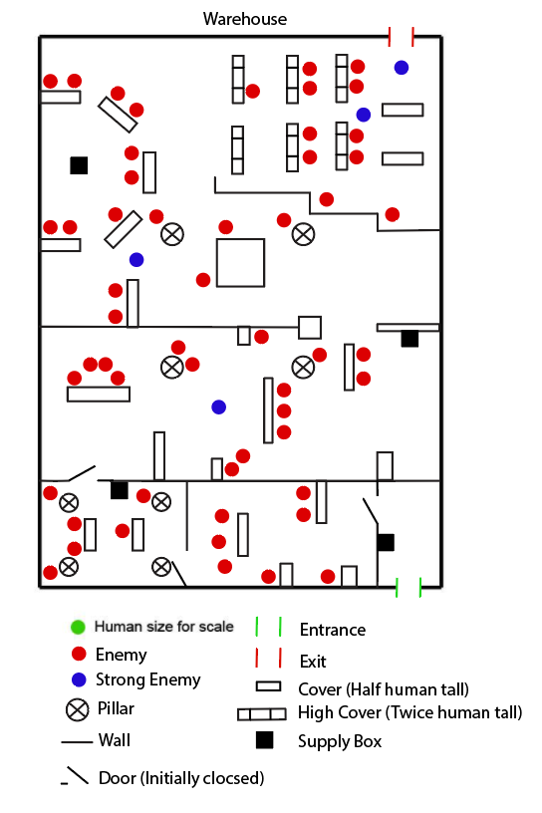

**I have attached an image file if Part 3 is not clear.**

**Part 4: Please attach a supporting document for the following prompt.**

*You are designing the in-game interfaces for social features. One particular feature allows you to:*

*See a list of all your friends online in the front end (main menu)*o *Add or remove players as friends*o *Prioritize some friends as “favorites” who will receive preferential treatment in-*

*game and in the list of friends*

*Using a simple wireframe, describe how the “favorited” players are treated relative to other players in any of the following: scoreboards, leaderboards, game stat comparisons, or any other place of your choosing where a list of players appears in a modern, next-generation console game.*

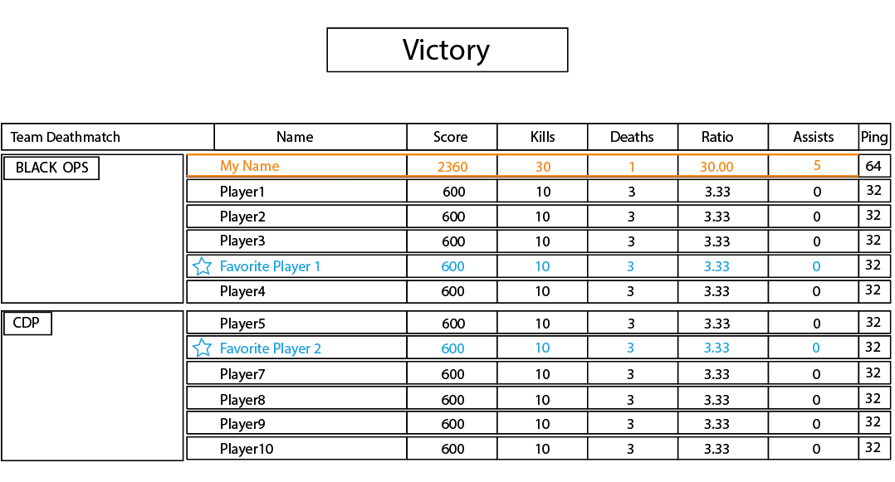

“Favorited” players are treated differently in two ways.

1. All the stats related to them, except for ping, are in a different font color (blue) than both the current player (orange) and other players (white).
2. There will be a star (having same color as the favorite player name) in front of the “favorited” player’s name, indicating that this player is “favorited”. The column remains empty for other non-favorite players and the current player.